Acknowledgements
Lt. Gen. Robert S. Coffey, Commanding General of 2nd Armored Division/4ID, who helped make me aware of how the Army displays and acts on critical information during Force XXI exercises at Fort Hood, TX and NTC. Others who were of tremendous help and support in this arena were: LTC Barry R. Hensley, CW Al Hubbard, CW Joe Kobsar, Cptn Dave Rogers and Johnny Sauceda.

Gen. Richard A. Cody, who required the installation of a KnowledgeWall™ in a MEC container. While serving as Vice Chief of Staff of the United States Army, Gen. Cody requested the installation of an advanced KnowledgeWall™ system in the Army Operation Center at the Pentagon.

Freeman Smith, Principal Electronic Engineer at Motorola/General Dynamics C4
Systems, who partnered with me in the development of a new system. We worked together designing the system and writing the software specification. I wrote the new control software in less than thirty days and assisted in system checkout and training.

Lt. Gen. James C. Riley, Commanding General of the V Corps in Germany, who requested thirty KnowledgeWall™ systems for V Corps use in Iraq. Others who were of tremendous help and support in this arena were: SM Alex Branch, CW Joe Kobsar, Col. Thomas A. Kruegler, Mr. Jim Jenkins, and the General Dynamics crew in Darmstadt Germany.

LTC Paul McGuire, with Joint Cruise Missile Defense and CRAM, who required a KnowledgeWall™ system to display information more effectively.

The U.S. Army, who saw value in my patented portable screen design and has purchased more than 4,000 screens for the current Trailer Mounted Support System (TMSS).
In July 2010, the ABCS™ system with the 60x45 BlackWatch™ screen (patent pending) was used by the Red Forces at Ft. Sill’s Fires Battle Lab. The system was instrumental in displaying battle information to the victorious Red Forces during the exercise. As a result, the Ft. Sill Fires Battle Lab purchased a three-screen BlackWatch™ system.

Pictured below is the new ABCS™ system with a single 60x45 screen display and two monitors. This system was integrated in the Johnson Outdoors/Eureka Tent booth at Modern Day Marine in Quantico, VA September 28 – 30, 2010. Due to a favorable reception at Modern Day Marine, ABCS™ was featured at the Best Warrior Competition at Fort Lee, VA; at SOFEX in Fort Bragg, NC; and at the Soldier Equipment & Technology Expo & Conference.

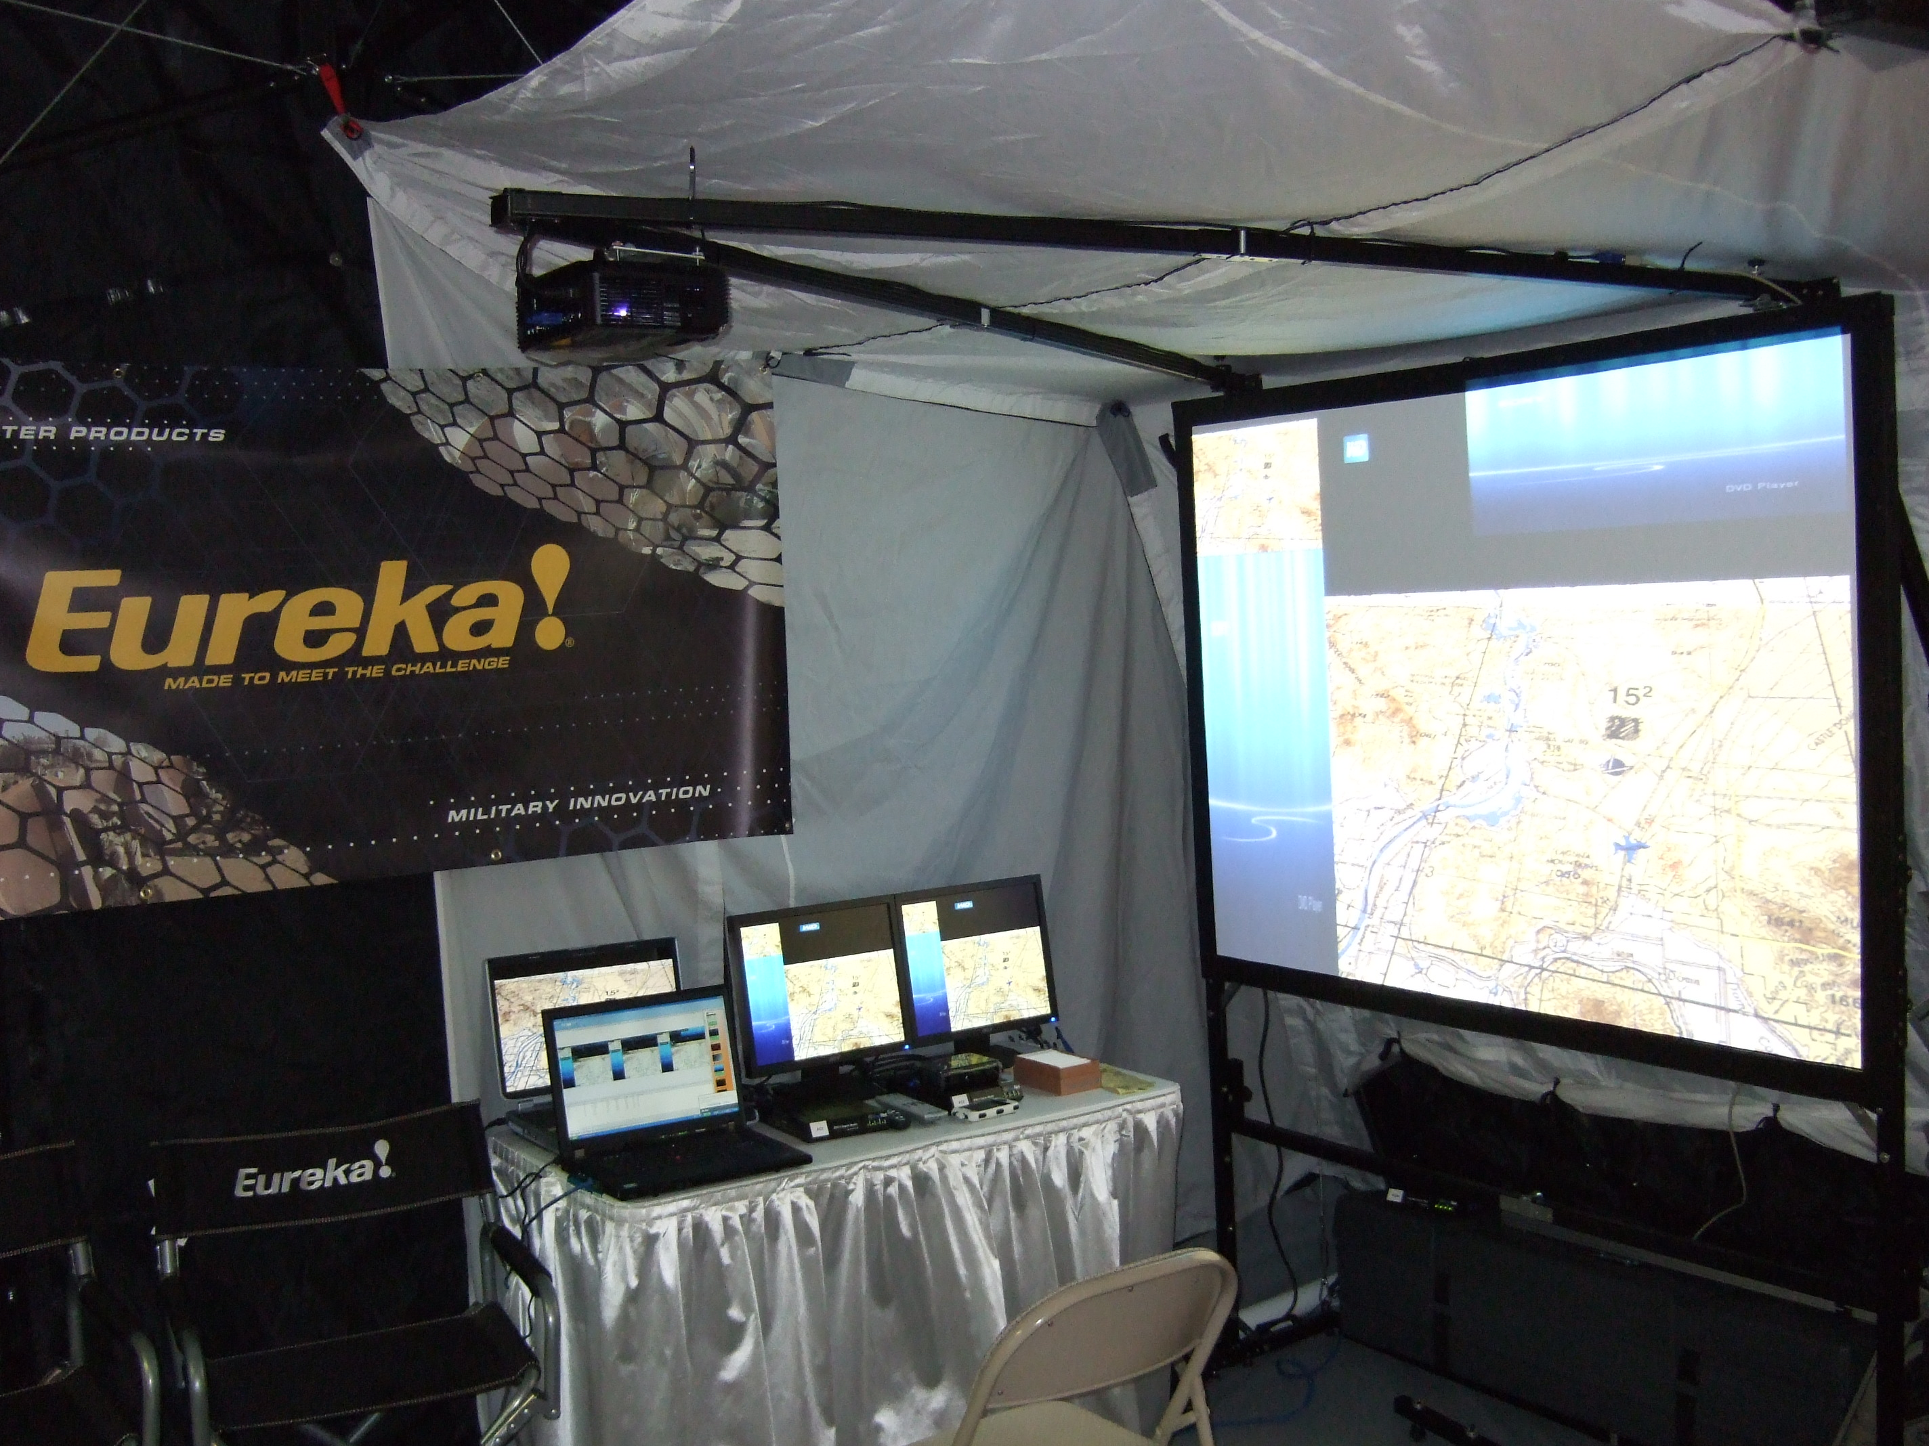

Shown here is the side view of the screen with the attached projector v-arm. The hinge pictured is the old type, while the new hinge is heavy-duty, black-powder coated, equipped with captive hardware, and does not scratch the screen surface. The quarter inch hole seen on the side of the screen frame allows for side-by-side configuration of the system (known as a KnowledgeWall™).

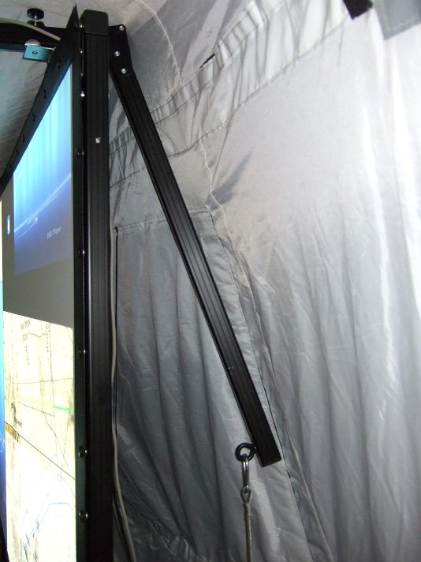

The BlackWatch™ screens are available in all form factors and sizes:
- 4:3 – 60x45, 72x 54, and 80x 60
- 5:4 - 60x 48 and 72x 57.6
- 16:10 – 72x 45, 80x 50, and 90x 56.25

Additionally, all sizes up to 120” are designed to fit in the same case.

Shown here is the unfolded BlackWatch™ screen frame with the optional leg extenders (on the floor below the screen). The BlackWatch™ screen can be raised in six inch increments up to two feet off the floor. There are also quarter inch holes in the screen sides to pin-register multiple screen frames for proper side-by-side configuration to make a KnowledgeWall™.

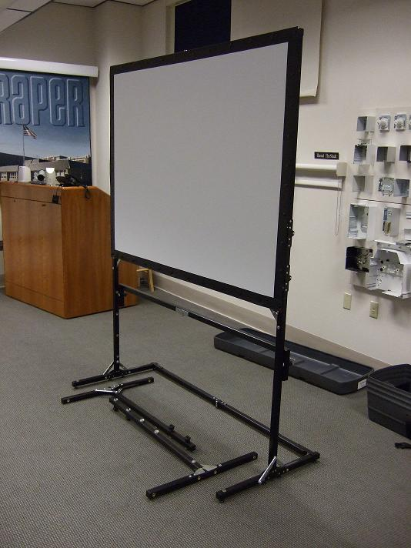

The old patented TMSS screen frame (pictured below on the left) is folded and lies floating in its case. As you can see, the frame can be easily damaged in the old case, which takes up more space than the new case.

The patent pending BlackWatch™ screen frame (pictured below on the right) is folded and packed securely in its case. Three straps hold the screen frame in place and protect the screen snaps.

Old TMSS case BlackWatch™ case
Length 49.75” 51”
Width 17.75’ 15”
Height 13” 12”
Volume 6.65 Cubic Feet 5.3 Cubic Feet

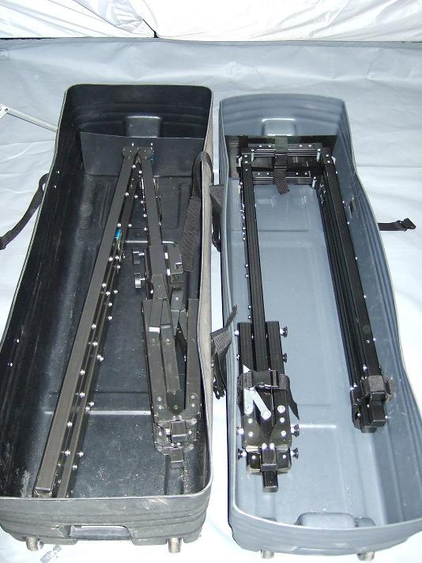

The BlackWatch™ projector v-arm (on the left) is folded and ready to put in the case. It folds much more efficiently, and takes up less space than the old TMSS folded projector v-arm (on the right).

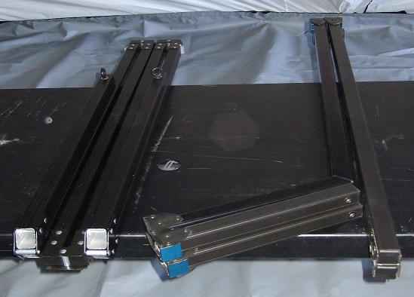

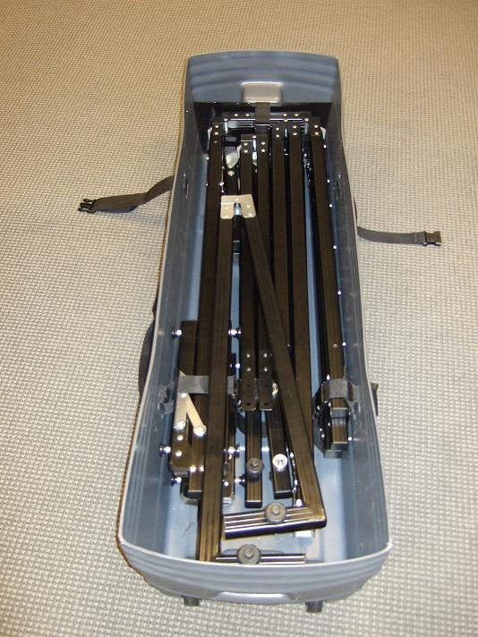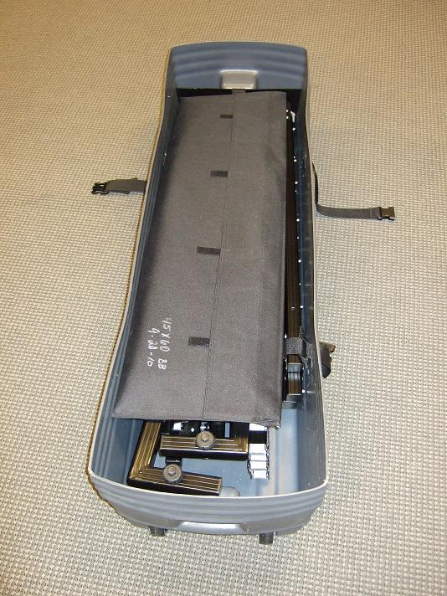

The complete lightweight BlackWatch™ portable 60” x 45” v-arm projector mounted screen easily disassembled in minutes and ready for transport to the next tactical operation.

The packed screen case (pictured below on the left) is the old patented screen used in the TMSS program. The case is completely full and is larger than the BlackWatch™ screen case (pictured below on the right), which is only half full.
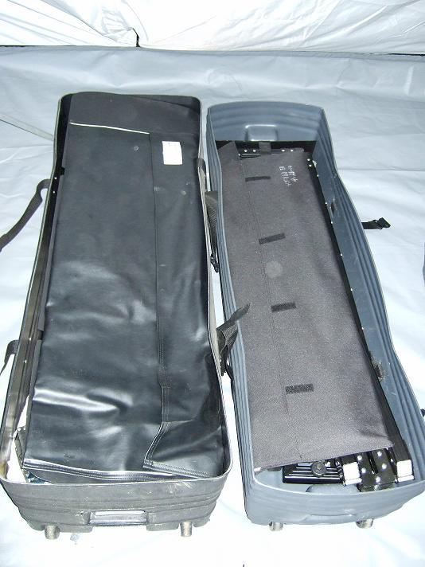

Pictured below is the ABCS™ with BlackWatch™ Digital System block diagram. ABCS™ operates at 110 & 220Volts. Additionally, the system is lightweight and easy to setup, configure, use, expand, and transport.

